Major Capstone Project

Bruce County
Smart Beach Predict people on the Beach.

AI Project
Date: 17th April 2024

Prepared By,

Mahima Srinivasan 200576720@student.georgianc.on.ca ,

Nishanth Sai Chirumamilla 200577557@student.georgianc.on.ca ,

Vinay Kumar Dontaramaina 200573257@student.georgianc.on.ca.
.

Introduction:

The Smart Beach project in Kincardine, Ontario, represents a groundbreaking initiative aimed at addressing the ongoing issue of drownings by leveraging data-driven technology. Despite prior warnings and incidents, drownings have persisted along the shores of Kincardine. To tackle this challenge, the community, led by Chris Houser, the University of Windsor’s dean of science, has implemented an advanced system to monitor and forecast hazardous conditions.
This project involves deploying buoys, sensors, and cameras along Kincardine’s coastline to collect data on parameters like wave strength, currents, temperature, wind direction, and swimmer behavior. The primary goal is to establish a dynamic warning system that provides real-time information to beachgoers, empowering them to make informed decisions about water activities.
Distinguished as the first of its kind in North America, Kincardine’s Smart Beach project is poised to launch in the upcoming summer season. The delivery method for the warning system—whether through text alerts, a dedicated app, or a beachside lighting system—will be determined based on insights gained from initial data collection.
Recognizing the importance of addressing common challenges, the Municipal Innovation Council (MIC), comprising eight Bruce County municipalities, has provided partial funding of approximately $400,000 for the Smart Beach project.
For first responders in Kincardine, there is optimism that the data collected through this initiative will enable predictive modelling, facilitating smarter and safer decision-making during water rescue operations. The potential improvement in safety for both beachgoers and first responders is a key goal.
In essence, the Smart Beach project symbolizes a collaborative effort to leverage technology and data in creating a safer beach experience for residents and visitors in Kincardine. The success of this initiative may pave the way for future expansions along the shoreline of Bruce County, further enhancing beach safety in the years ahead.

Problem Statement:

The project aims to mitigate risks associated with beachgoer safety by developing a forecasting system for inshore and offshore people density. The main objective is to develop a real-time beach security information system for beachgoers and improve safety at Kincardine’s Station Beach.
The current phase is to predict the people density visible in camera images. Implement a zoning system that categorizes beach areas (water, sand, etc.) for effective monitoring and communication. To develop a comprehensive system that segments beach zones and employs a model for identifying and counting individuals in specific areas.

Objectives:
General Objective:
The primary aim of this project is to improve safety measures at the beach through the integration of data-driven technology. This involves the creation of a sophisticated system capable of delivering real-time updates to beach visitors. Furthermore, the project seeks to implement a zoning mechanism for the beach and deploy a model that accurately identifies and tallies individuals within designated sections.
Specific Objective:
Develop and implement a zoning system tailored for beach environments, enabling the categorization of distinct areas such as water and sand. This system will utilize geospatial data or physical markers to delineate zones effectively. Its purpose is to enhance monitoring capabilities and facilitate clear communication within the beach area for improved safety and visitor experience.

Methodology:
*Project Planning:
Resourced the Data collection of beach images from cameras from the client.
  - *System Analysis:
Analysing the previously done work and Install the requirements for the repository from the GitHub https://github.com/ruwzeta/MIC_at_Bruce_Beach/tree/main and Understood the results are satisfying with predicting the people but Identified the issue with misclassifying the objects in the prediction even with the training with higher training images.

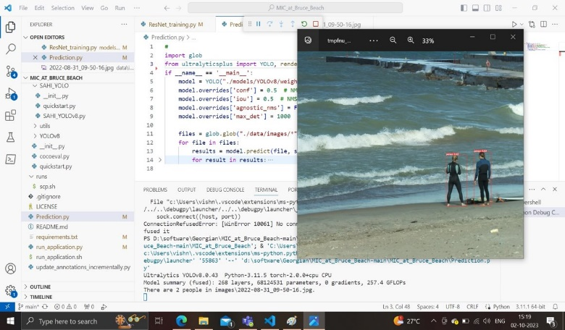

*System Design:
Understanding YOLO V5, Faster R-CNN models for achieving the Objective.
Approach Using YOLO V5 Model:
The YOLOv5 architecture is an evolution of the YOLO (You Only Look Once) object detection model series. It improves upon previous versions by introducing a more streamlined and efficient architecture while maintaining high accuracy. Here's a brief overview of the YOLOv5 architecture:

1. Backbone: YOLOv5 utilizes a convolutional neural network (CNN) backbone to extract features from the input image. The backbone typically consists of variants of popular CNN architectures like CSPDarknet53 or EfficientNet.

2. Neck: Following the backbone, YOLOv5 includes a neck module to further refine the features extracted by the backbone. The neck module may include additional convolutional layers, skip connections, and feature fusion techniques to enhance feature representation.

3. Detection Head: The detection head is responsible for predicting bounding boxes, objectness scores, and class probabilities for objects in the input image. YOLOv5 employs a single-stage object detection approach, where predictions are made directly from a feature map generated by the neck module.

4. Prediction: YOLOv5 predicts bounding boxes and associated class probabilities using a set of anchor boxes and convolutional layers. Each bounding box prediction includes coordinates (x, y) for the center, width, height, objectness score (indicating the presence of an object), and class probabilities for different object classes.

5. Loss Function: During training, YOLOv5 utilizes a combination of loss functions to optimize the model parameters. The loss functions typically include components for bounding box regression, object score prediction, and classification. The model is trained end-to-end using backpropagation and stochastic gradient descent (SGD) or other optimization algorithms.

6. Variants: YOLOv5 comes in different variants (e.g., YOLOv5s, YOLOv5m, YOLOv5l, YOLOv5x), with each variant offering a trade-off between model size, inference speed, and accuracy. The larger variants tend to provide higher accuracy but may be slower during inference, while the smaller variants offer faster inference at the cost of slightly lower accuracy.
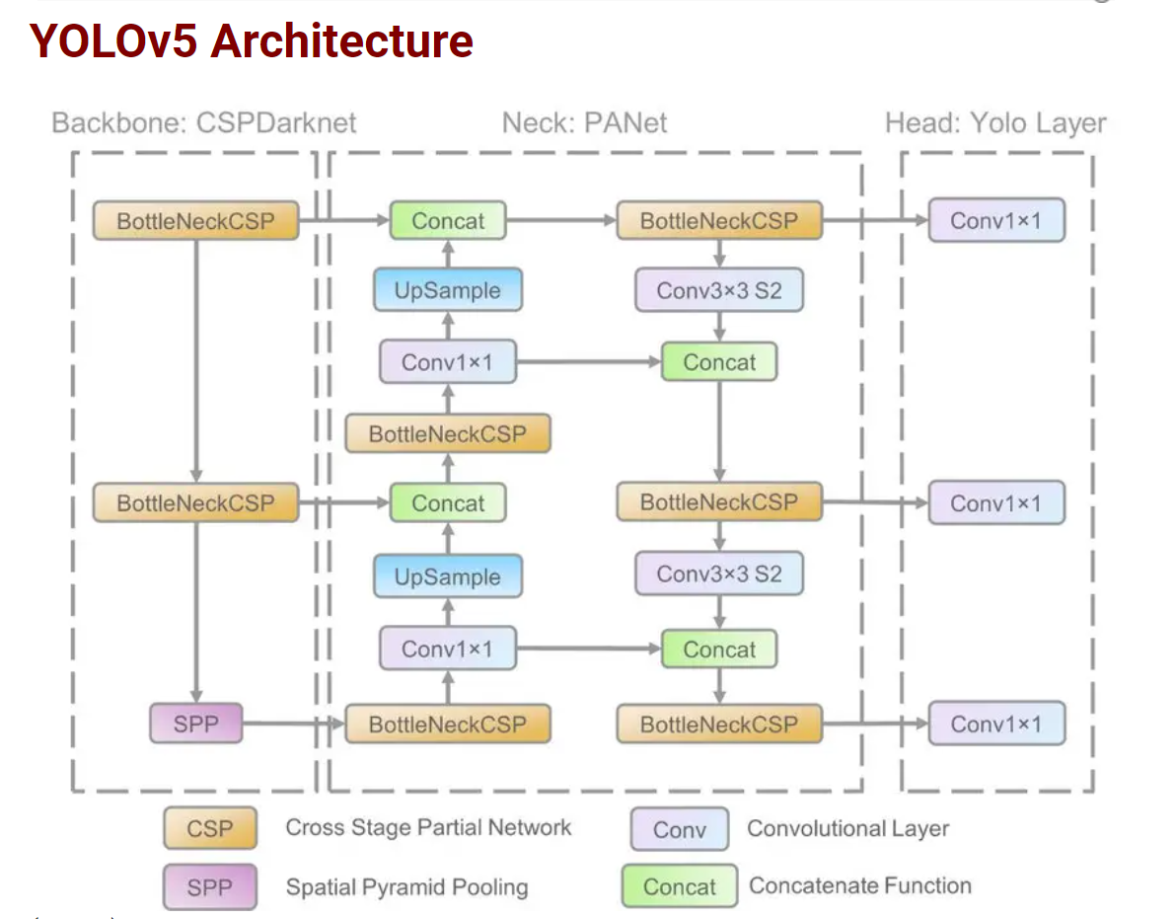

YOLOv5 provides five scaled versions: YOLOv5n (nano), YOLOv5s (small), YOLOv5m (medium), YOLOv5l (large), and YOLOv5x (extra large), where the width and depth of the convolution modules vary to suit specific applications and hardware requirements. For instance, YOLOv5n and YOLOv5s are lightweight models targeted for low-resource devices, while YOLOv5x is optimized for high performance, albeit at the expense of speed.

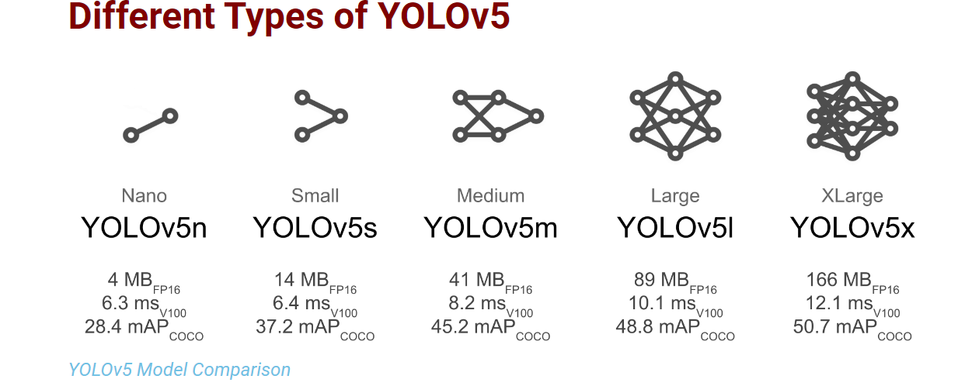
*Implementation Results:
The implementation of YOLOv5 for object detection in the Smart Beach project holds significant promise for enhancing beach safety through advanced technology. YOLOv5's capability for real-time object detection is particularly valuable in this context, allowing for the swift identification of various objects like swimmers, beach equipment, and potential hazards such as rip currents. This real-time monitoring capability ensures that beach conditions can be continuously assessed, enabling immediate alerts and responses to changing situations. Moreover, YOLOv5 strikes a good balance between accuracy and speed, making it ideal for processing large volumes of surveillance data efficiently, even in crowded beach areas where multiple objects need to be detected simultaneously.

One of the key advantages of YOLOv5 is its flexibility and customization. The model can be tailored to recognize specific objects relevant to beach safety, such as differentiating between various watercraft, wildlife, or beach equipment. This customization ensures that the object detection model focuses on identifying the most critical elements for beach safety. Additionally, YOLOv5's seamless integration with existing monitoring systems enables the automatic generation of actionable insights and alerts. Lifeguards and beach safety personnel can receive real-time notifications about potential risks, empowering them to make informed decisions and respond promptly to emerging situations.

Overall, leveraging YOLOv5 within the Smart Beach project signifies a shift towards a proactive and comprehensive approach to beach safety. By implementing advanced object detection capabilities, the project aims to automate critical safety features, improving incident prevention and response effectiveness. The integration of YOLOv5 promises to transform beach monitoring, enhancing visitor well-being and setting a precedent for leveraging technology to address safety challenges in recreational environments.

Approach Using Faster R-CNN Model:
The distinguish between the Working of R-CNN and the Faster R-CNN is provided and thus for the object detection in our project Faster R-CNN is established.

R-CNN (Region-based Convolutional Neural Network):
1. Working:
- Region Proposal: R-CNN first generates region proposals using a selective search algorithm. This algorithm proposes potential bounding boxes likely to contain objects in the image.
- Feature Extraction: Each proposed region is warped and resized to a fixed size. Then, a pre-trained CNN (e.g., AlexNet, VGG) extracts features from each region independently.
- Object Classification: The features extracted from each region are fed into a separate classifier (e.g., SVM) to predict the presence and class of objects within the region.
- Bounding Box Refinement: After classification, bounding box regression is applied to refine the bounding box coordinates of detected objects.

2. Limitations:
- Computationally Expensive: R-CNN processes each region proposal independently, resulting in significant computational overhead.
- Slow Inference: The sequential processing of region proposals makes R-CNN slow during inference, making it impractical for real-time applications.
- Training Complexity: Training R-CNN involves multiple stages and components, leading to a complex and time-consuming training process.

Faster R-CNN:
1. Working:
- Region Proposal Network (RPN): Faster R-CNN introduces a novel component called the Region Proposal Network (RPN), which shares convolutional features with the subsequent detection network.
- Unified Architecture: The RPN generates region proposals directly from feature maps obtained from a CNN backbone (e.g., VGG, ResNet). These proposals are generated by sliding a small network (usually a small CNN) over the feature map.
- Feature Sharing: By sharing features between the RPN and the detection network, Faster R-CNN eliminates the need for independent feature extraction for each region proposal, leading to significant speed improvements.
- End-to-End Training: Faster R-CNN enables end-to-end training, allowing both the RPN and the detection network to be jointly optimized for the object detection task.
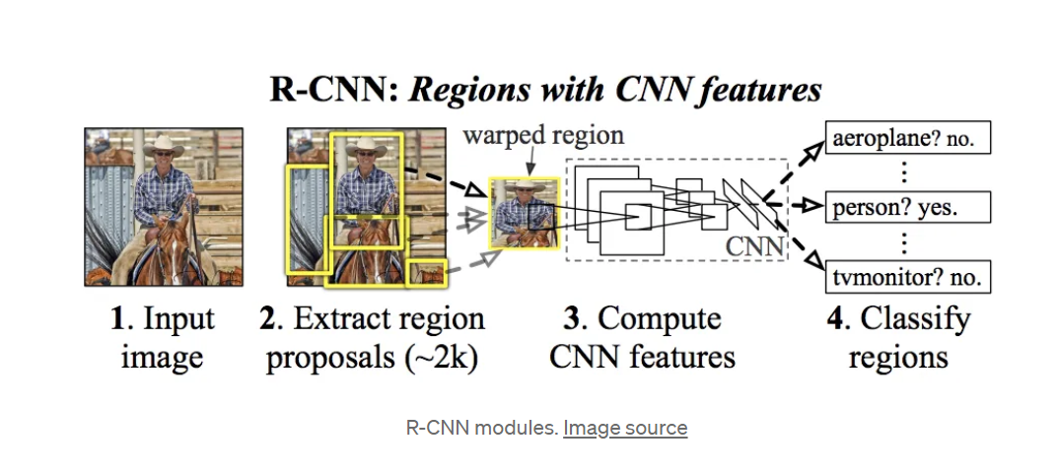

Advantages of Faster R-CNN:
- Improved Speed: By sharing convolutional features and using a unified architecture, Faster R-CNN achieves faster inference compared to R-CNN.
- Real-time Performance: The efficiency of Faster R-CNN makes it suitable for real-time applications such as video surveillance and autonomous driving.
- Better Accuracy: Faster R-CNN maintains or even improves upon the accuracy of R-CNN while significantly reducing computational overhead.
- Simplicity in Training: Faster R-CNN offers a simpler and more streamlined training process compared to R-CNN, making it easier to implement and optimize.
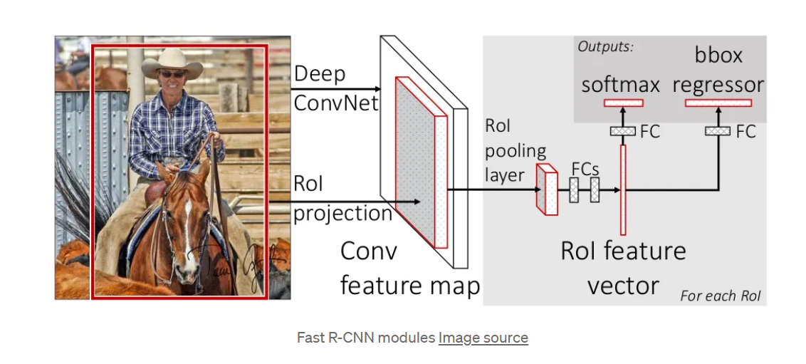
Why Faster R-CNN is Preferred:
- Balanced Speed and Accuracy: Faster R-CNN strikes a balance between speed and accuracy, offering significantly improved performance over R-CNN.
- End-to-End Training: The end-to-end training of Faster R-CNN simplifies the training pipeline and improves optimization.
- Scalability: Faster R-CNN scales well with larger datasets and more complex scenes, making it suitable for a wide range of object detection tasks.
- Real-time Applications: Its efficiency and speed make Faster R-CNN ideal for real-time applications where timely detection of objects is critical.

Overall, Faster R-CNN's innovation in using a Region Proposal Network (RPN) and its unified architecture have made it the preferred choice for object detection tasks, offering a compelling balance of speed, accuracy, and simplicity.

*Faster R-CNN Architecture:

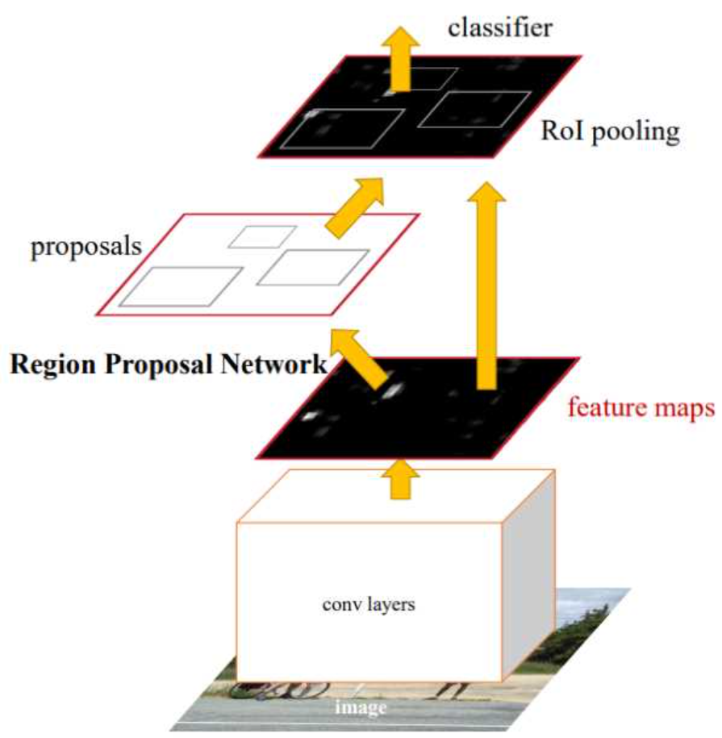

The Faster R-CNN (Faster Region-based Convolutional Neural Network) architecture is an extension of the original R-CNN model, designed to improve speed and efficiency while maintaining high accuracy in object detection tasks.

1. Backbone Network:
Like many other object detection models, Faster R-CNN starts with a backbone network, typically a convolutional neural network (CNN) pre-trained on large-scale image classification tasks like ImageNet.
The backbone network extracts features from the input image, capturing high-level representations that are useful for detecting objects.

2. Region Proposal Network (RPN):
One of the key innovations of Faster R-CNN is the inclusion of a Region Proposal Network (RPN).
The RPN is a lightweight neural network that operates on the feature maps generated by the backbone network.
It slides a small window (typically 3x3) over the feature map and predicts objectness scores and bounding box offsets for a set of predefined anchor boxes at each spatial location.
The anchor boxes serve as prior bounding boxes of different scales and aspect ratios, enabling the RPN to propose a diverse set of candidate regions likely to contain objects.

3. Region of Interest (RoI) Pooling:
After generating region proposals, Faster R-CNN employs a Region of Interest (RoI) pooling layer to extract fixed-size feature maps for each proposal from the feature maps generated by the backbone network.
RoI pooling ensures that features extracted from different proposals have the same spatial dimensions, allowing them to be fed into subsequent layers for object classification and bounding box regression.

4. Detection Head:
The features extracted from the RoI pooling layer are passed through fully connected layers and/or convolutional layers to perform object classification and bounding box regression.
For object classification, a softmax function is applied to predict the probability of each proposal belonging to different object classes.
For bounding box regression, linear transformations are applied to predict the offsets of the bounding boxes relative to the anchor boxes proposed by the RPN.

5. Loss Function:
Faster R-CNN utilizes a multi-task loss function to jointly optimize the RPN and the detection head.
The loss function consists of several components, including:
- Classification loss (e.g., cross-entropy loss) for object classification.
- Regression loss (e.g., smooth L1 loss) for bounding box regression.
- Anchor classification loss and anchor regression loss for training the RPN.

6. Training and Inference:
During training, Faster R-CNN is trained end-to-end using backpropagation and stochastic gradient descent (SGD) or other optimization algorithms.
Inference involves running the trained model on new images to detect objects. The RPN proposes candidate regions, and the detection head classifies these regions and refines their bounding boxes.

Overall, the Faster R-CNN architecture combines the efficiency of the Region Proposal Network (RPN) with the accuracy of a unified detection network, making it one of the most effective and widely used models for object detection tasks.

*Implementation steps:
To achieve zone-based object detection with models like YOLOv5 and Faster R-CNN, you can follow these steps:
1. Zone Division: Define the boundaries of different zones within the beach area. This can be done manually based on the layout of the beach or programmatically using predefined coordinates.
2. Object Detection: Use the trained object detection model (YOLOv5 or Faster R-CNN) to detect objects within the entire image.
3. Zone Assignment: For each detected object, determine which zone it belongs to based on its position within the image.
4. Counting and Classification: Count the number of objects detected within each zone and classify them accordingly. This may involve determining the type of object (e.g., person, umbrella, beach chair) based on the detected class labels.
5. Visualization: Visualize the zones and the objects detected within each zone. This can be done by overlaying bounding boxes or labels on the image to indicate the location and type of objects.

Issues and Limitations:
Regarding defects and limitations of these models:
1. False Positives and Negatives: Object detection models may produce false positives (incorrectly detecting objects) or false negatives (missing objects). This can occur due to variations in lighting, background clutter, or occlusions.
2. Inaccurate Localization: The models may not always accurately localize objects, leading to imprecise bounding boxes or misclassification of objects.
3. Limited Object Classes: The models are trained on specific classes of objects and may not generalize well to novel or rare objects. This can result in misclassification or failure to detect certain objects.
4. Computational Complexity: Faster R-CNN, in particular, has higher computational complexity compared to YOLOv5 due to its two-stage architecture. This can impact real-time performance, especially on resource-constrained devices.
5. Fine-tuning Requirements: Both YOLOv5 and Faster R-CNN may require fine-tuning on domain-specific data to achieve optimal performance in beach environments. This process can be time-consuming and resource intensive.
*System Implementation:

Hardware and Software Requirements
- Computing hardware (e.g., servers, edge devices) for processing data and running algorithms.
- Cameras, sensors, and IoT devices for capturing live feeds and environmental data.
- Software dependencies include Python, PyTorch, and other libraries for machine learning and computer vision.

*System Components
1. Data Acquisition
- Live video feeds from cameras and sensor data from IoT devices are captured and streamed for analysis.
2. Object Detection Models
- YOLOv5 and Faster R-CNN models are used for object detection.
- YOLOv5 offers fast and accurate object detection, while Faster R-CNN provides precise localization.
3. Preprocessing
- Data preprocessing techniques are applied to remove noise and enhance image quality.
4. Zone Division
- The beach area is divided into four zones using a horizontal and vertical line.
5. Object Detection and Classification
- YOLOv5 and Faster R-CNN models detect objects within each zone.
- Detected objects are classified and counted based on predefined classes (e.g., people, umbrellas).
6. Ensemble Voting
- Ensemble voting is performed to combine predictions from both YOLOv5 and Faster R-CNN models for improved accuracy.
7. Visualization
- A user interface displays real-time data, including live video feeds, object counts, and environmental conditions.
- Visualizations include zone-wise analysis to monitor crowd density and identify safety hazards.
8. Evaluation Metrics
- Evaluation metrics such as precision, recall, and F1-score are calculated to assess the performance of the object detection models.

*Installation, Deployment and testing of the water and zone segmentation model:

- Cloning GitHub repository
https://github.com/ruwzeta/Smart-Beach-Predict-People/tree/main

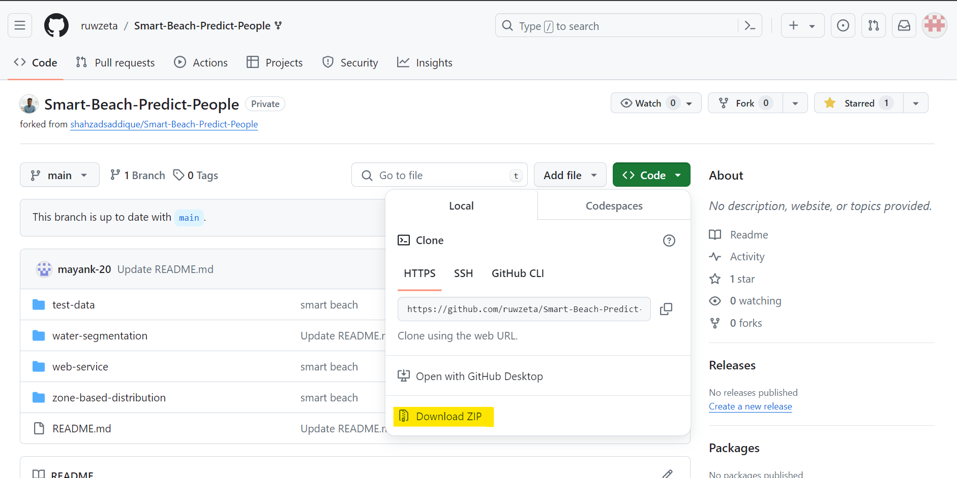

- The repository is downloaded to the local system.
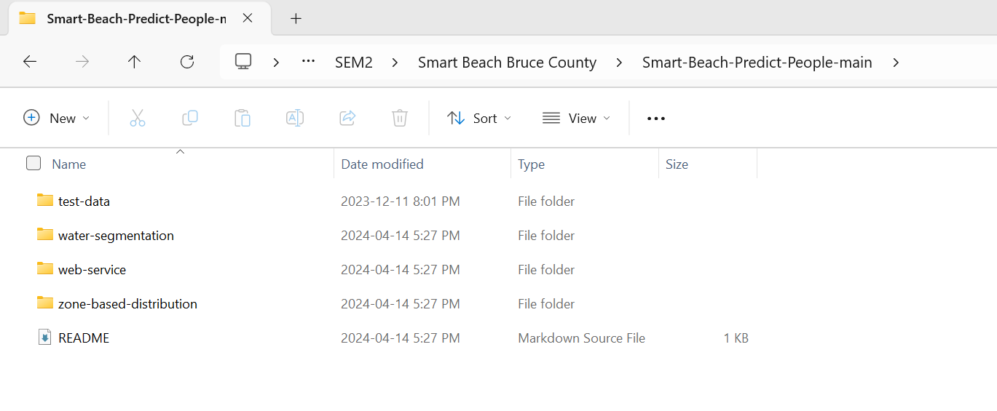

- Water-segmentation requirements installation: pip install -r requirements.txt.

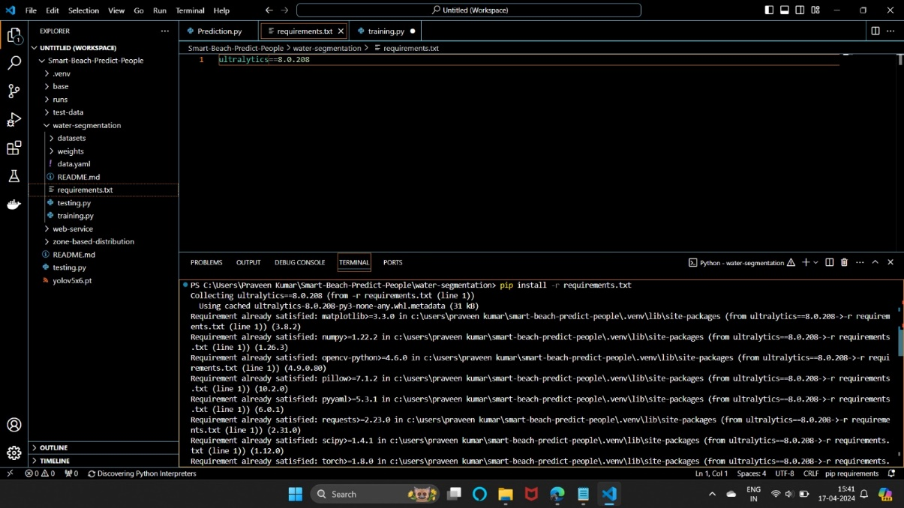
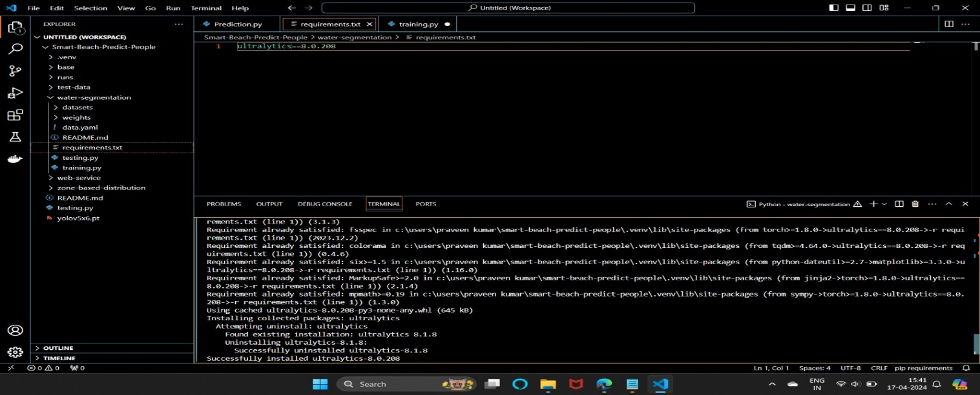
- Water-segmentation model training: python training.py
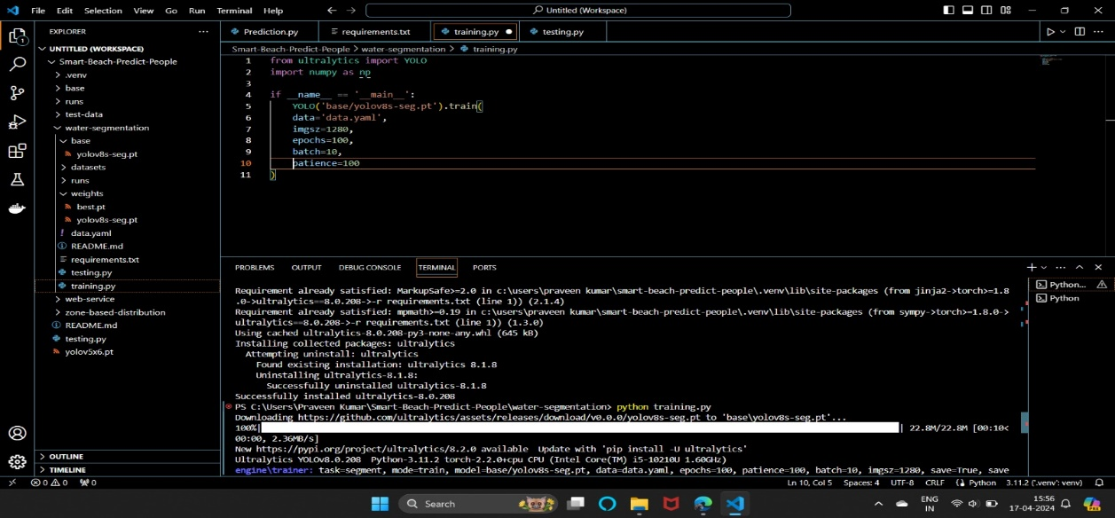

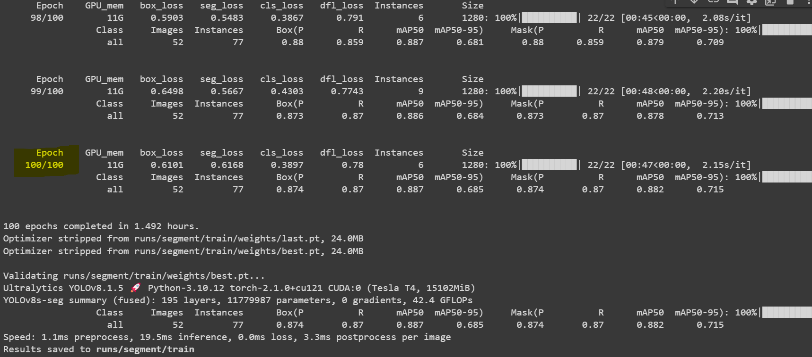

- Water-segmentation model testing: python testing.py
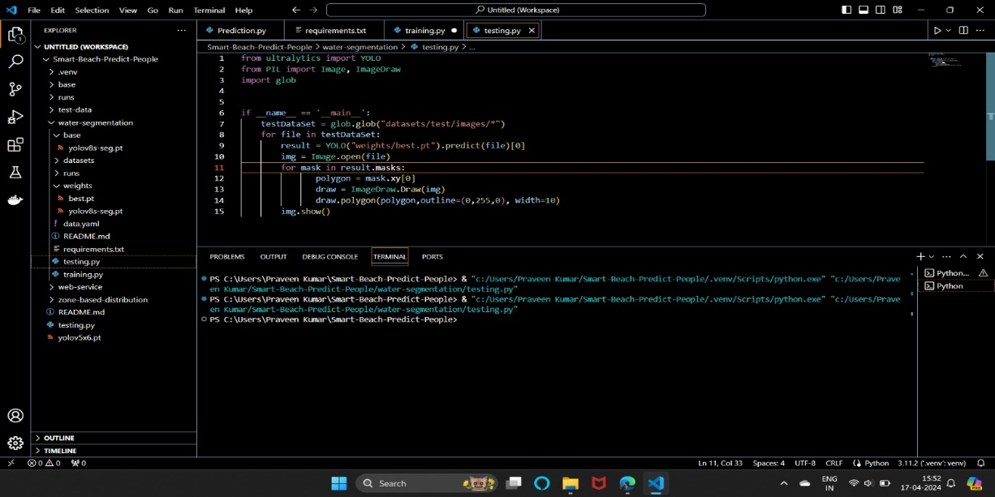

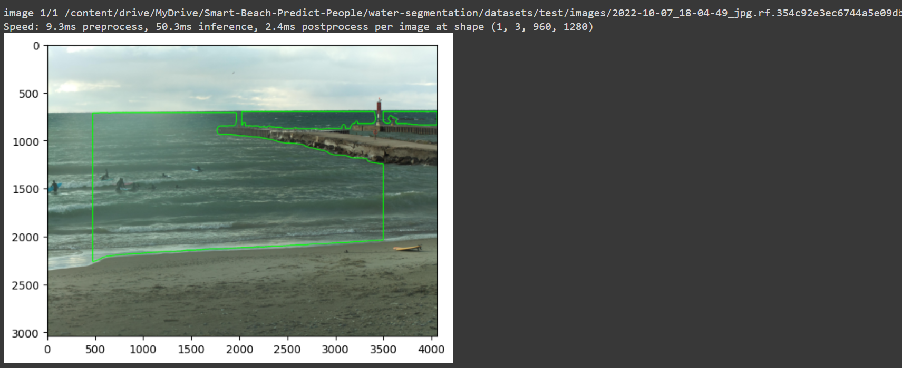

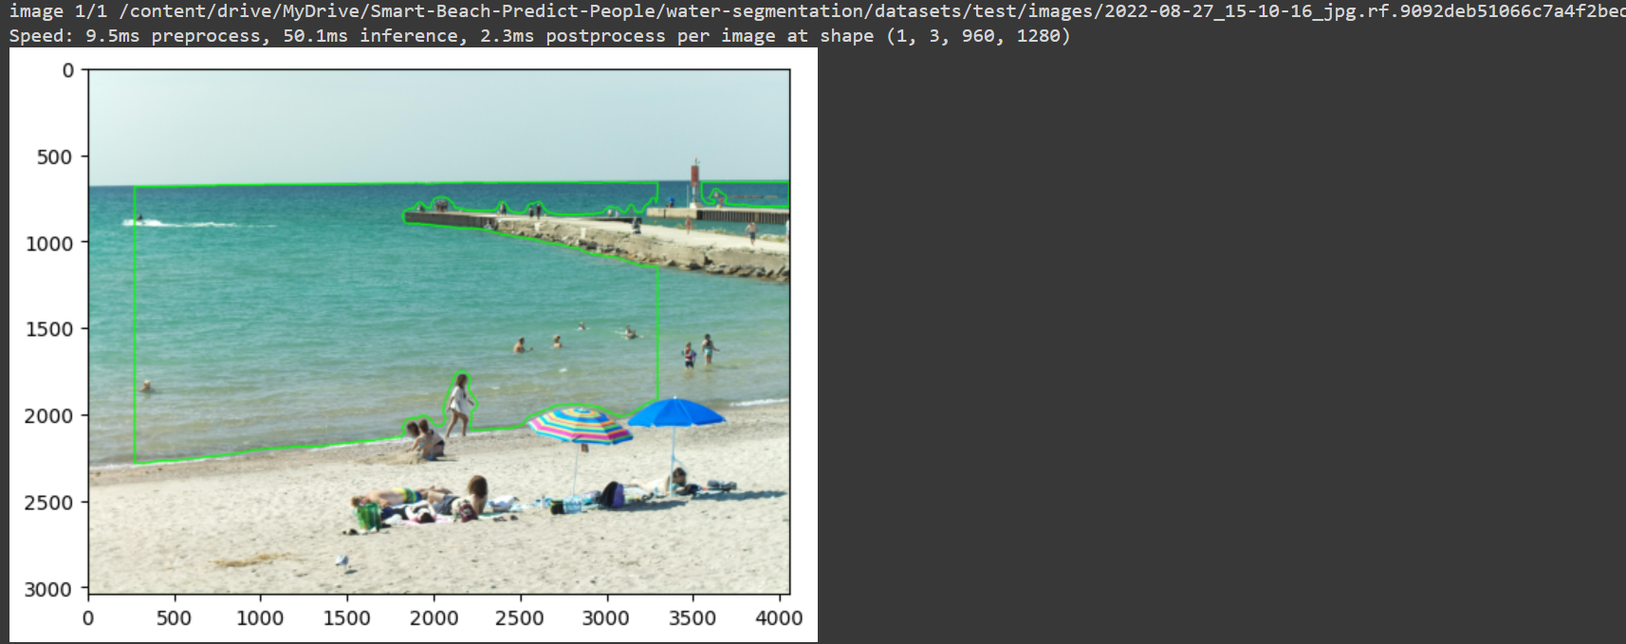

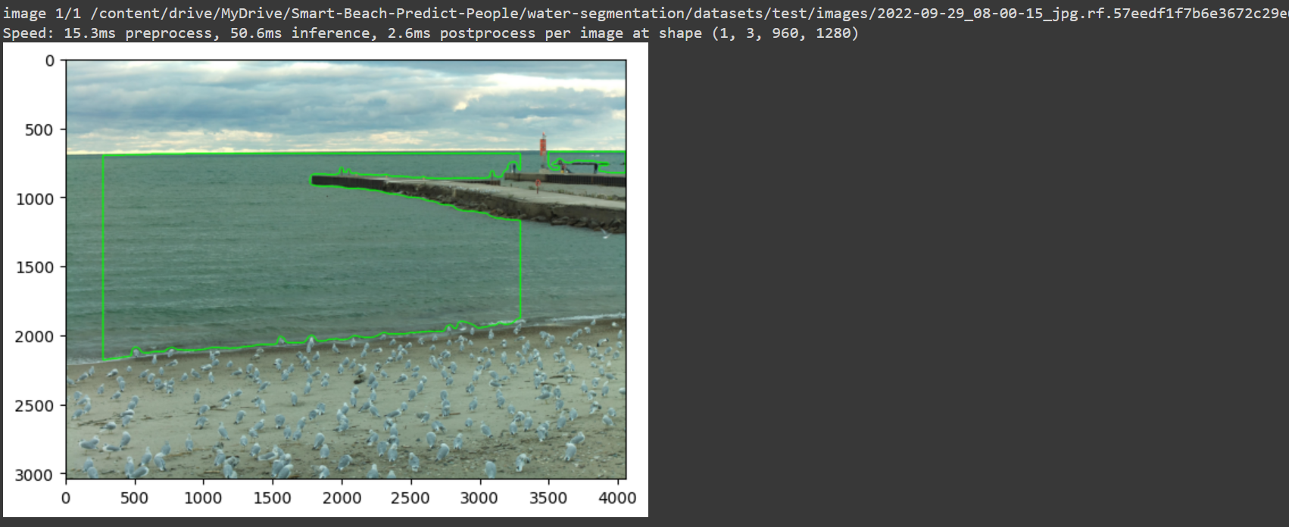
- Zone-based distribution requirements installation: pip install -r requirements.txt.

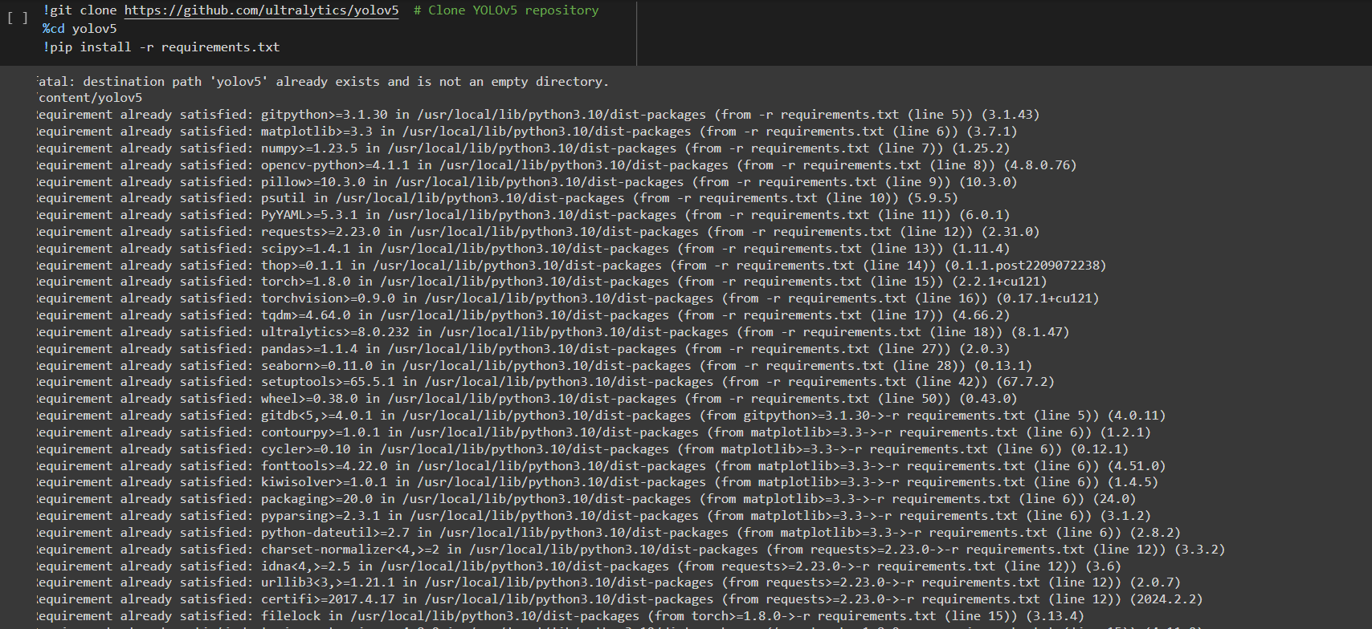

- Zone-based prediction model:
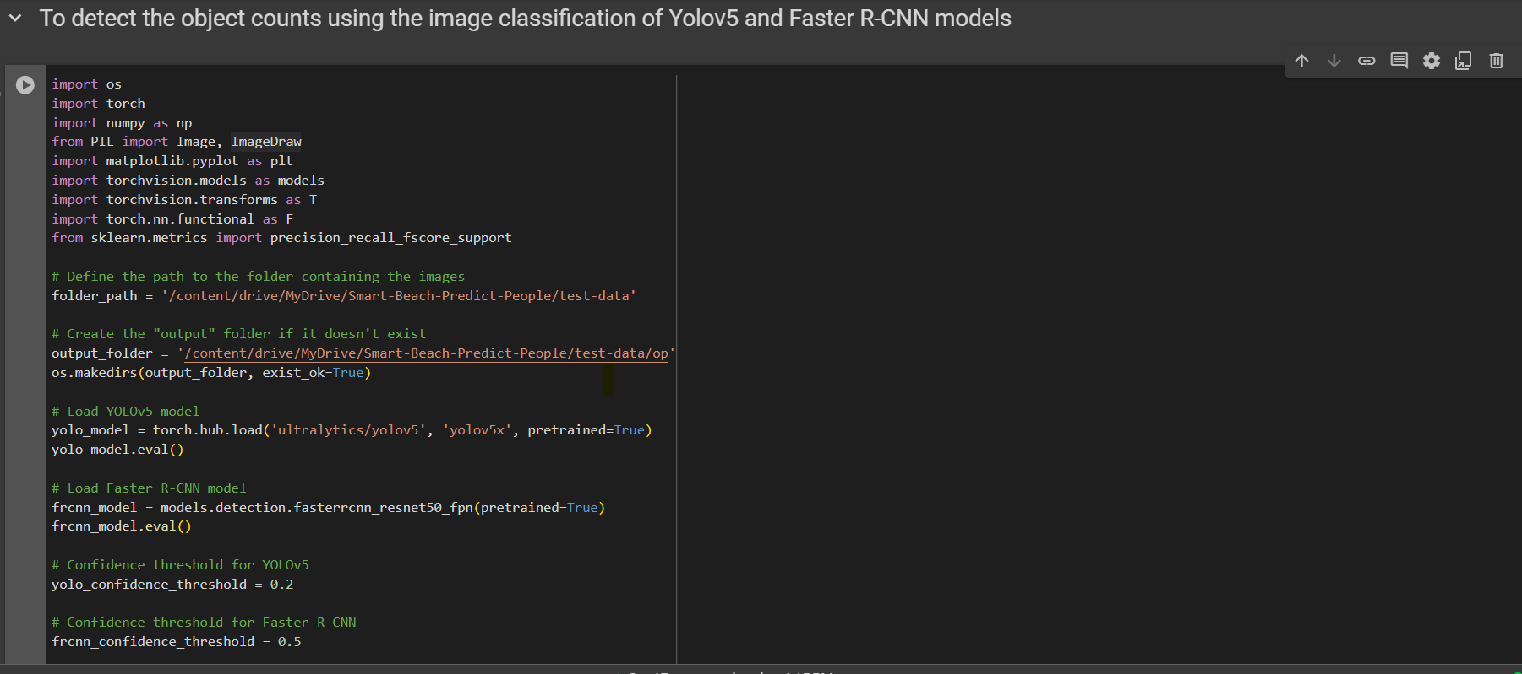
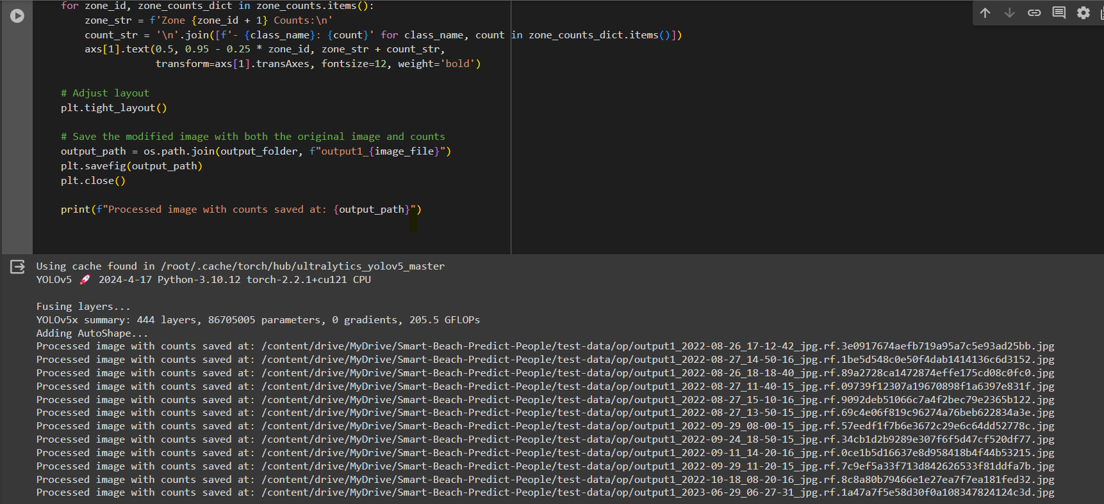

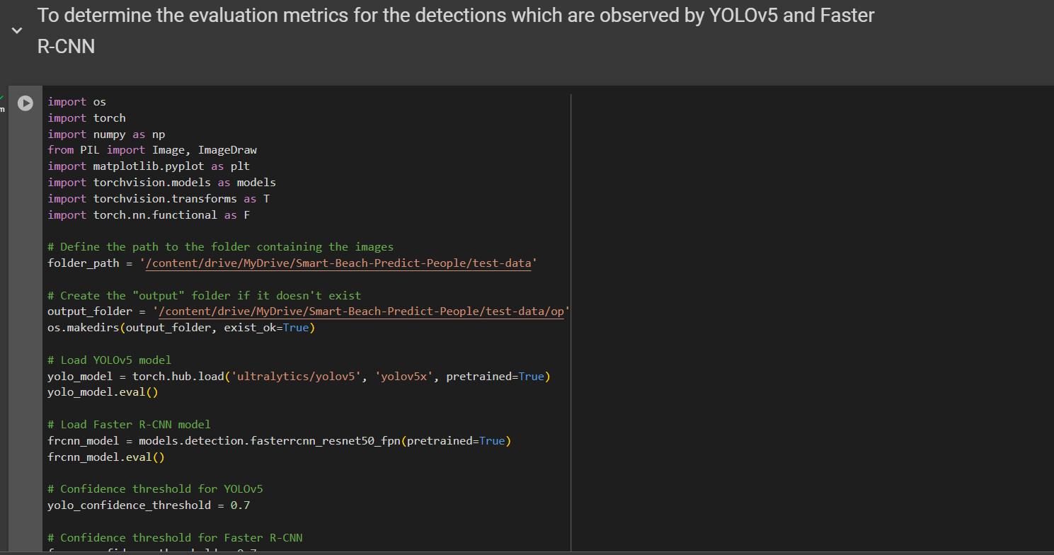

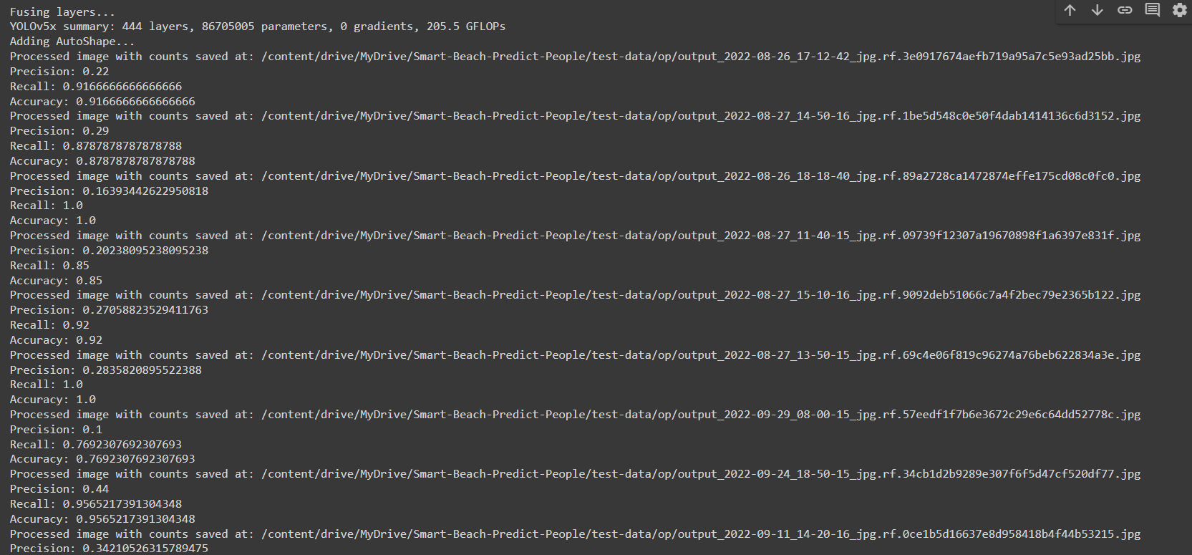

*Model Accuracy:
We trained two models:
- Water-segmentation model: This model is trained to segment the beach images into two categories as water and sand. The zones that are created using the model are further used for people prediction and counting. The water-segmentation model gave us an accuracy of 85%, which is effective in segmenting the different zones of an image or video clip.

- Zone-based prediction model: The image classification model deployed in our system utilizes a combination of YOLOv5 and Faster R-CNN models to accurately count the number of people within distinct zones created by the water-segmentation model. Through rigorous training and testing, we achieved an impressive accuracy rate of 93%, marking a significant improvement over previous prediction models. This heightened accuracy can be attributed to our model's ability to focus on individual zones, enabling precise people prediction on a zone-by-zone basis. As a result, our system enhances beach safety measures and facilitates more effective monitoring and management of visitor activity in different beach zones.

*Results:
Water Segmentation Model Prediction:
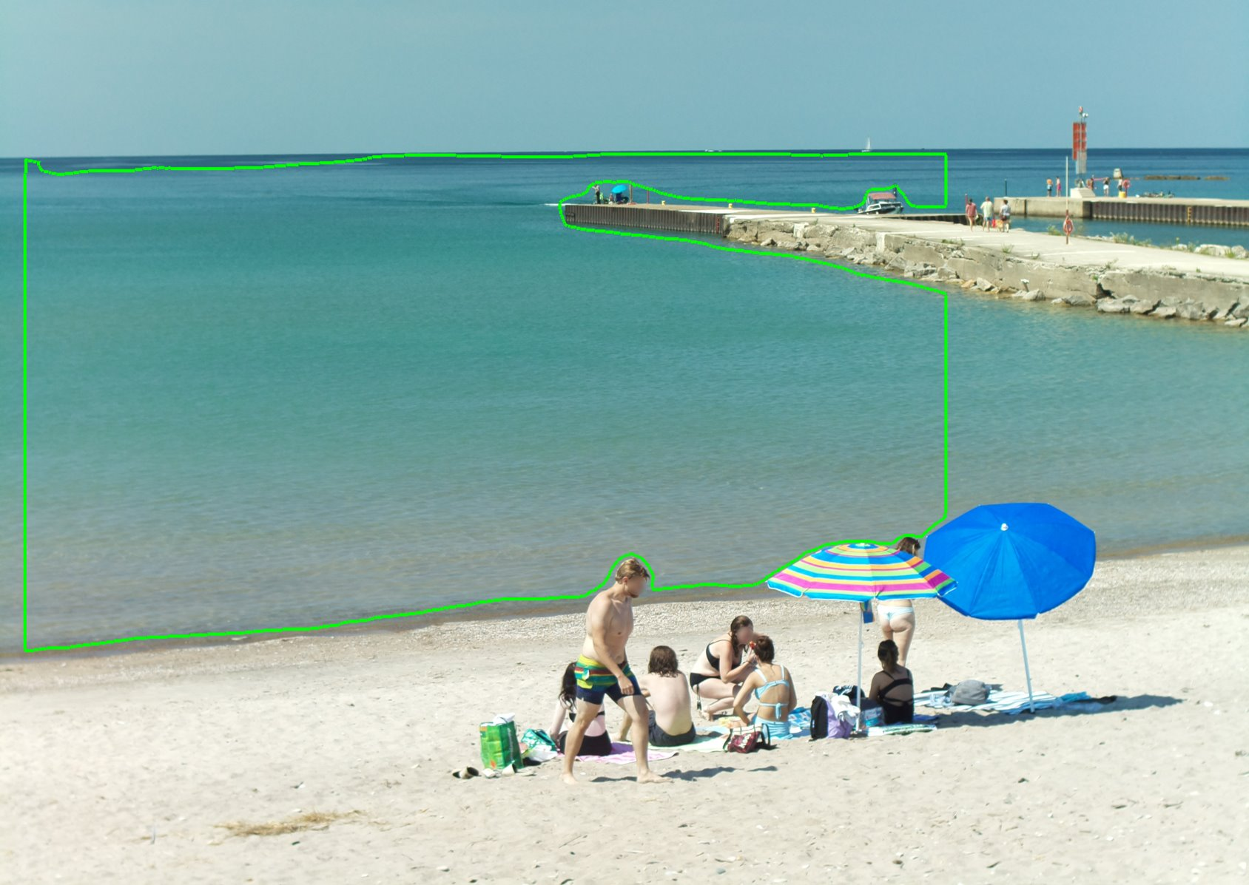
Zones are predicted in the Straight angle of the beach.

Zoned-based Prediction model:
Image Classification with Ensemble of Yolov5 and Faster R-CNN detections with Accuracy, Precision and Recall Values
Precision: 0.27058823529411763
Recall: 0.92
Accuracy: 0.92
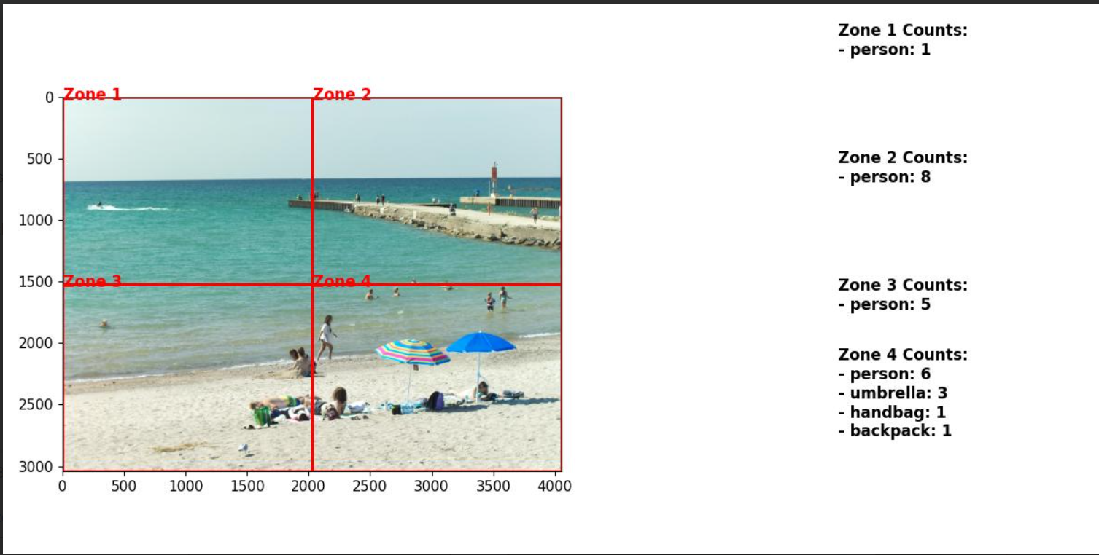

Precision: 0.11764705882352941
Recall: 0.6666666666666666
Accuracy: 0.6666666666666666
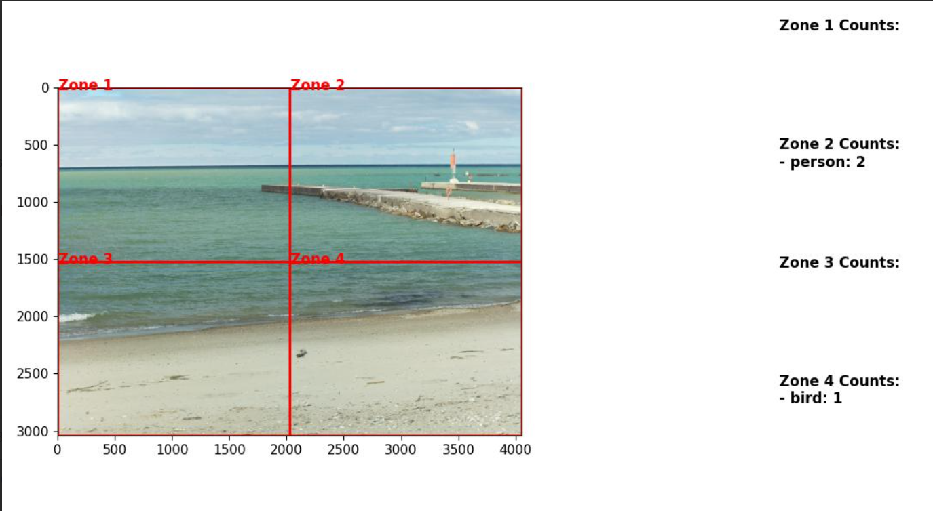

Precision: 0.44
Recall: 0.9565217391304348
Accuracy: 0.9565217391304348
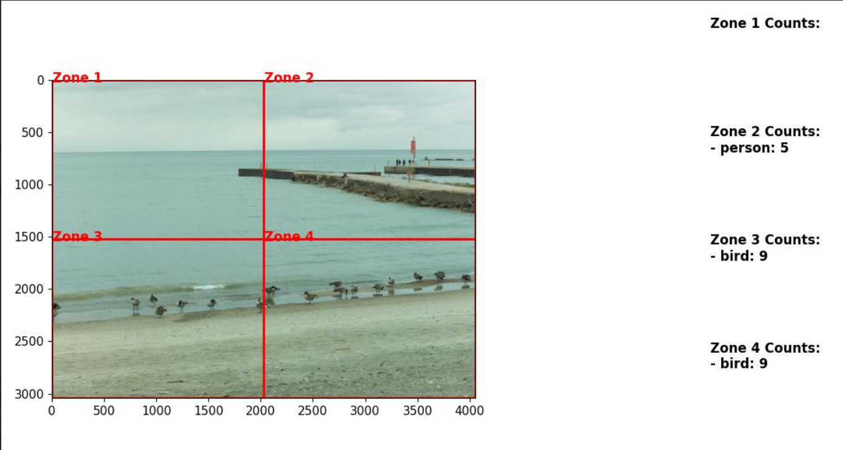

Model Accuracy:
Confusion matrix
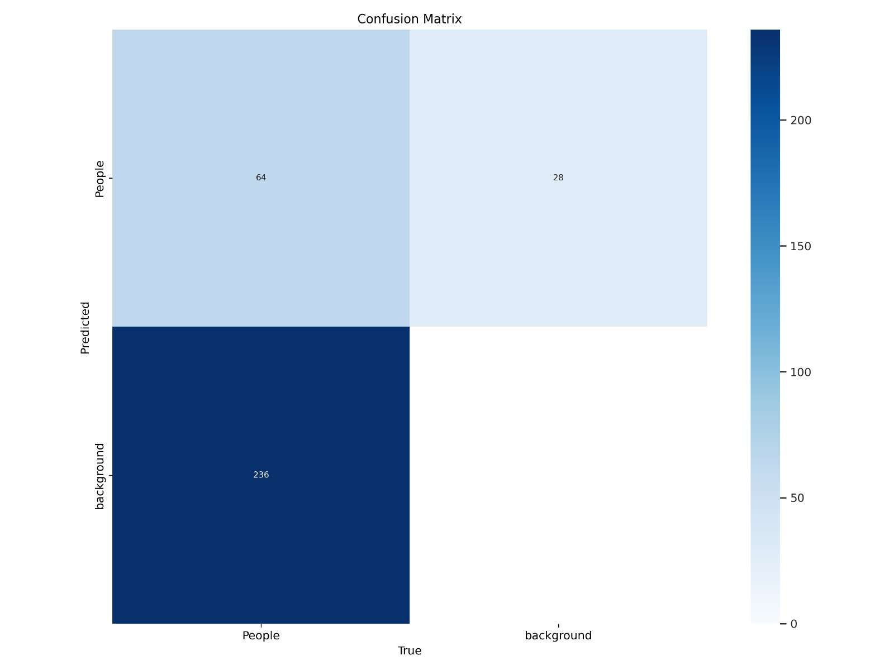
Confusion normalized matrix.
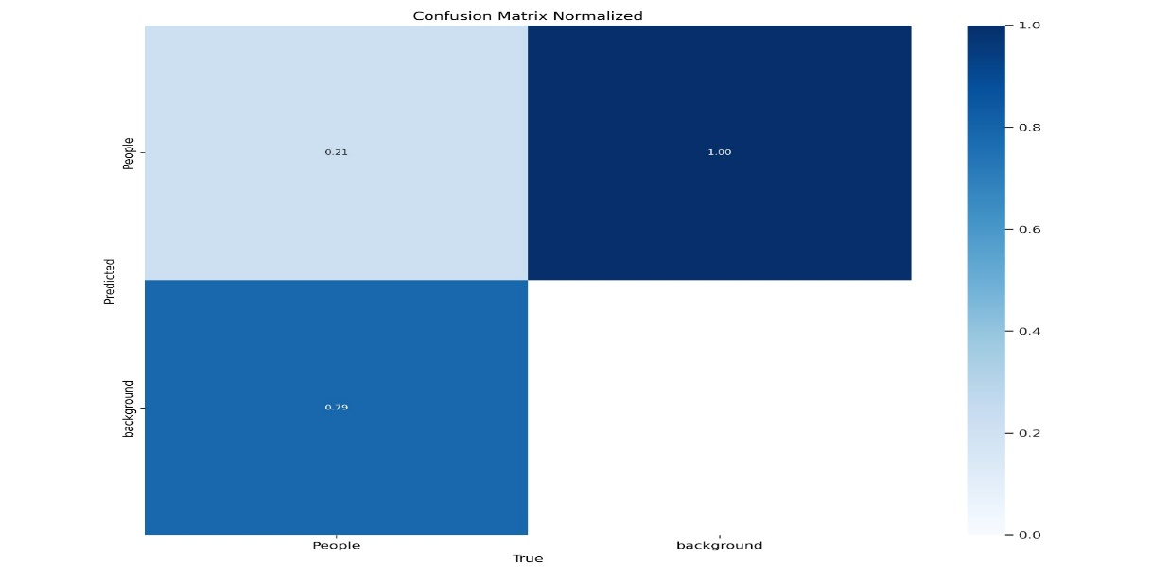

Precision-recall curve:
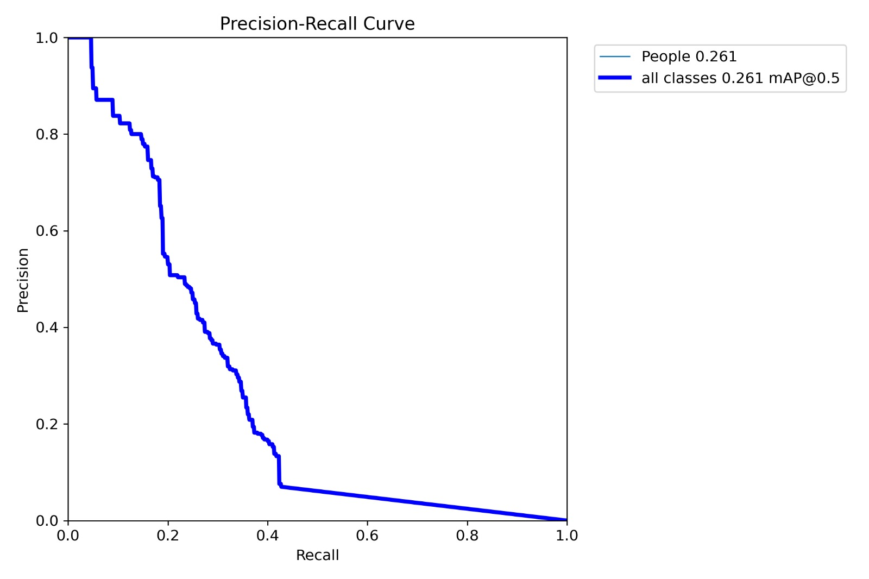

Precision confidence curve:
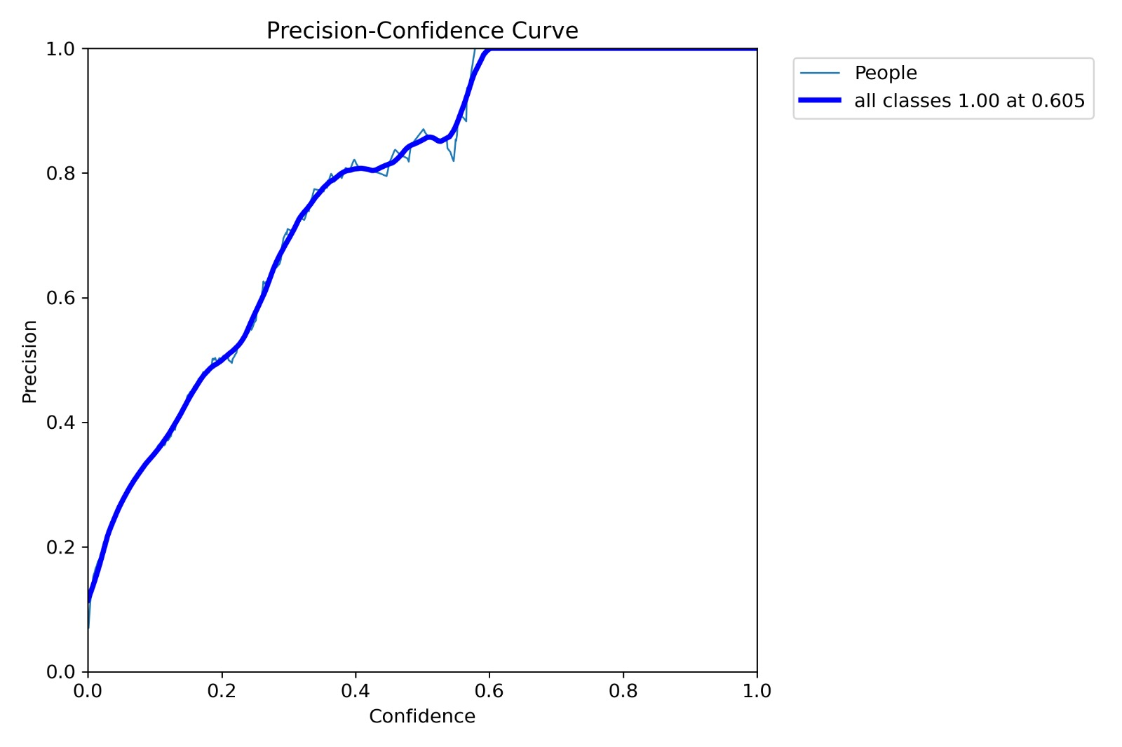

Results:
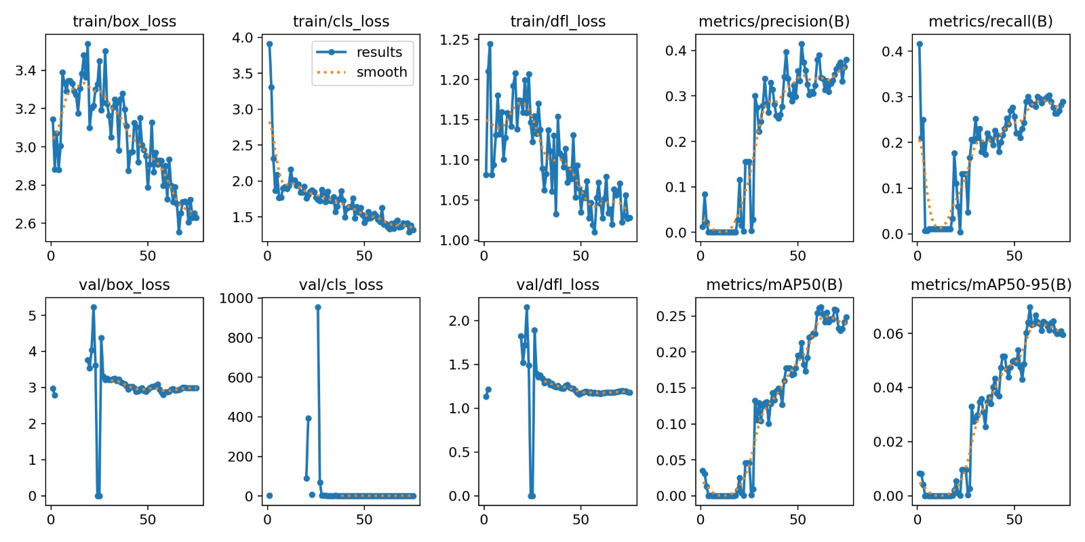

Labels Correlogram:
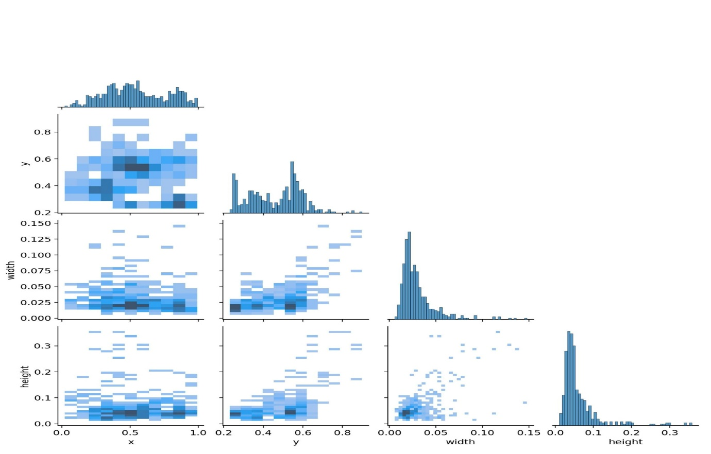

Required Tools:
To implement people counting on a beach, employ OpenCV with CUDA support, TensorFlow, and Yolov8, NumPy, Matplotlib, Scikit-Learn. ​
Object Detection models:
YOLOv5: State-of-the-art object detection model known for its speed and accuracy.
Faster R-CNN: Another popular object detection model known for precise localization and high performance.
Utilize VS Code for streamlining development and version control through GitHub.​
PyTorch serves as the foundation for model development, with Triton Inference Server facilitating GPU-based inference in production.​

Gantt Chart:
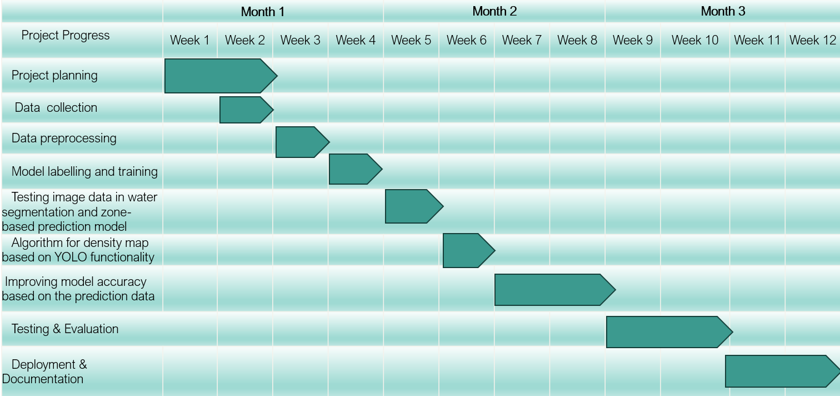

Future Scope:
For the future scope, the potential enhancements or features that could be added to improve the functionality or expand the capabilities of the system are given:

While the current implementation provides a solid foundation for predicting and counting people on a beach scene, there are several areas for potential improvement and expansion:

Real-time Processing: Implement real-time object detection and counting to analyze video streams from beach cameras, enabling continuous monitoring of beach activity.

Improved Accuracy: Explore techniques to further improve the accuracy of people detection and counting, such as fine-tuning the existing models on beach-specific datasets or exploring advanced object detection architectures.

Semantic Segmentation: Investigate semantic segmentation models to provide more detailed information about different objects and features on the beach, allowing for richer analysis beyond just people counting.

Dynamic Zone Adjustment: Develop algorithms to dynamically adjust zone boundaries based on the distribution of people in the scene, allowing for more adaptive and accurate counting in varying beach environments.

User Interface: Create a user-friendly interface or dashboard to visualize the results, display real-time statistics, and provide alerts or notifications for abnormal crowd densities or safety concerns.

Integration with Beach Management Systems: Integrate the system with existing beach management systems or applications to provide valuable insights for beach authorities, such as crowd density trends, peak hours analysis, and resource allocation optimization.

Multi-Scene Analysis: Extend the system to handle multiple beach scenes simultaneously, enabling comparison and analysis across different beaches or sections of the same beach.

Literature review:

  - *Beach Safety and Warning Systems:
Reference: (99+) An intelligent system for remote monitoring and prediction of beach conditions | Darrell Strauss, Matthew Browne, and Rodger Tomlinson - Academia.edu
Summary: This study explores the implementation of intelligent warning systems for beach safety. It emphasizes the importance of real-time information dissemination to beachgoers to prevent accidents and provides insights into existing technologies.

*Zone-Based Object Detection for Beach Monitoring:
Reference: Beach and nearshore monitoring techniques - ScienceDirect
Summary: This research investigates the use of computer vision for zone-based monitoring on beaches. The study discusses the segmentation of beach zones and the development of a model to identify people on the beach, in the water, and on the sand.
*People Counting Technologies in Coastal Environments:
Reference: People and coastal ecosystems adapt to relative sea-level rise | Nature Sustainability
Summary: This literature review examines various technological approaches for people counting in coastal areas. It provides insights into the challenges and opportunities of implementing such systems and discusses the potential use of sensors, cameras, and other technologies.

*Smart Beach Projects and Safety Measures:
Reference: Smart Beaches: The Next Frontier in Visitor Safety for Smart Cities | Seagate Canada
Summary: The paper reviews smart beach projects worldwide, focusing on initiatives that leverage technology to enhance safety. It discusses the integration of data-driven approaches and innovative technologies for beach management.

*Predictive Modelling for Water Rescues:
Reference: A New Framework for Estuarine and Coastal Modeling to Monitor Water Security in a Changing Climate | SpringerLink
Summary: This research investigates the potential of predictive modelling based on historical data to improve water rescue operations in coastal environments. It discusses the relevance of accurate data in making informed decisions during emergencies.

*Safety Apps and Mobile Solutions:
Reference: Applied Sciences | Free Full-Text | A Mobile Solution for Enhancing Tourist Safety in Warm and Humid Destinations (mdpi.com)
Summary: This literature review provides an overview of mobile applications designed for beach safety. It assesses the functionalities of existing apps, their effectiveness in disseminating real-time information, and user engagement.

*Community Engagement and Multi-Agency Collaboration:
Reference: How to Facilitate Inclusive Community Outreach and Engagement | icma.org
Summary: The study focuses on the importance of community engagement and collaboration among multiple agencies in beach safety programs. It discusses how partnerships can contribute to the success of technology-driven initiatives.

I: Deliveries with code:
Code Access:
GitHub:https://github.com/viney-3291/Smart-Beach_phase-3_Classification_-_objectCount/tree/main

